**UNIVERSITI TEKNOLOGI MARA**

Virtual buddy APP: chat management system for uITM STAFF USING PROGRESSIVE WEB APPLICATION

**WAN PUTERA NUR SYAFIQ BIN WAN JEFERI**

**BACHELOR OF COMPUTER SCIENCE (HONS.)**

**MARCH 2022**

**Universiti Teknologi MARA**

**Virtual Buddy App: Chat Management System for UiTM Staff using Progressive Web Application**

**Wan Putera Nur Syafiq bin Wan Jeferi**

**Thesis submitted in fulfilment of the requirements for Bachelor of Computer Science (Hons.) Faculty of Computer and Mathematical Sciences**

**March 2022**

**SUPERVISOR APPROVAL**

**VIRTUAL BUDDY APP: CHAT MANAGEMENT SYSTEM FOR UITM STAFF USING PROGRESSIVE WEB APPLICATION**

By

**WAN PUTERA NUR SYAFIQ BIN WAN JEFERI**

**2020836988**

The thesis was prepared under the supervision of the project supervisor, Professor Madya Dr.Suriyani binti Ariffin. It was submitted to the Faculty of Computer and Mathematical Sciences and was accepted in partial fulfilment of the requirements for the degree of Bachelor of Computer Science (Hons.).

Approved by

………………………………

Professor Madya Dr.Suriyani binti Ariffin.

Project Supervisor

JANUARY 23, 2022

**STUDENT DECLARATION**

I certify that this thesis and the project to which it refers is the product of my own work and that any idea or quotation from the work of other people, published or otherwise are fully acknowledged in accordance with the standard referring practices of the discipline.



………………………………

WAN PUTERA NUR SYAFIQ BIN WAN JEFERI

2020836988

JANUARY 23, 2022

**ACKNOWLEDGEMENT**

Alhamdulillah, all praise and blessings to Allah for the successful completion of this thesis. I am grateful to God for all the opportunities, hardships, and strength that have been bestowed upon me for me to complete this thesis. During this process, I learned a great deal, not only in terms of academics but also in terms of personality. My heartfelt thanks to the holy prophet Muhammad (peace be upon him), whose manner of life has been as a constant source of inspiration for me. I owe a debt of gratitude to all of those who have assisted me in finishing my thesis. It is a joy to express gratitude to everyone who made this thesis possible. I'd want to express my gratitude to my supervisor, Professor Madya Dr. Suriyani Binti Ariffin, who has always supplied me with ideas, helpful comments, advice, patience, and, most significantly, positive encouragement and a warm heart to help me accomplish this thesis. From the beginning until the end of the semester, I would want to express my gratitude to Dr Siti Khatijah Nor Binti Abdul Rahim, my CSP600 lecturer, for her constant knowledge sharing, encouragement, and motivation. Next, I want to express my thanks to all my family members, who have supported me from the beginning till I am able to finish everything that I have started.

**ABSTRACT**

People all over the world can now connect more readily with each other thanks to the advent of virtual intermediaries such as chat rooms in today's technological era, where technology is continually evolving. Even yet, there are certain disadvantages to using the chat room. In a chat room, cases of cyberbullying and disseminating bogus news are common. As a result, a chat control system will be built to prevent the problem from spreading further. Because it can be used on both PCs and mobile devices, this system employs the Progressive Web Application technique to help users. Front-end users can utilise this mechanism to report cases of chat room abuse to the system administrator. The system administrator will then review reports submitted by front-end users and ban offenders from using the chat room in the future. The Software Development Life Cycle (SDLC) approach will be utilised to ensure the smooth development of this application. An expert will run a function and usability test to evaluate this system.

**TABLE OF CONTENTS**

CONTENT PAGE

SUPERVISOR APPROVAL ii

STUDENT DECLARATION iii

ACKNOWLEDGEMENT iv

ABSTRACT v

TABLE OF CONTENTS vi

LIST OF FIGURES ix

LIST OF TABLES x

LIST OF ABBREVIATIONS xi

CHAPTER ONE: INTRODUCTION

1.1 Project Background 1

1.2 Problem Statement 2-3

1.3 Project Objectives 3

1.4 Scope of Study 3

1.5 Significance of Study 4

1.6 Summary 4

CHAPTER TWO: LITERATURE REVIEW

2.1 Social Community 5

2.1.1 Definition of Social Community 5

2.1.2 Online Community 5

2.1.2.1 Type of Online Community 5

2.1.2.1.1 Support Community 6

2.1.2.1.2 Discussion Community 6

2.1.2.1.3 Action Community 6

2.1.2.2 Example of Online Community 6

2.1.2.2.1 Visa Developer Community 6

2.1.2.2.2 Telstra CrowdSupport Community 6

2.1.2.2.3 Action Community 7

2.2 Chat Management 7

2.2.1 Definition of Chat Management 7

2.2.2 Current Development of Chat Management 8

2.1.2.1 Type of System 8

2.1.2.1.1 Progressive Web Application (PWA) 8

2.1.2.1.1 Native Apps 8

2.1.2.1.1 Web Apps 8-9

2.1.2.2 Type of Web Development Framework 9

2.1.2.2.1 Laravel 9

2.1.2.2.2 CodeIgniter 9-10

2.1.2.2.3 CakePHP 10

2.3 Virtual Buddy 10

2.3.1 Definition of Virtual Buddy 10-11

2.4 Progressive Web Application (PWA) 11

2.4.1 Advantages of Progressive Web Application 11

2.4.1.1 Like A Native 11

2.4.1.2 Quick and Easy to Install 11-12

2.4.1.3 Working Everywhere 12

2.4.1.4 Operating Offline 12

2.4.2 Progressive Web Application Major Components 12

2.4.2.1 Service Workers 12-13

2.4.1.1 Web Application Manifest 13

2.4.1.1 App Shell 13

2.5 Web Framework 14

2.5.1 Definition of Web Framework 14

2.5.2 Comparison of Web Framework 14-15

2.6 Similar System 16

2.6.1 Instamobile : Chat App Admin Panel 16-17

2.6.2 ArrowChat : Admin 17-18

2.6.3 Comparison Between Similar Applications 18-19

2.7 Summary 19

CHAPTER THREE: METHODOLOGY

3.1 Research Framework 20

3.2 Phase 1 Requirement Analysis 21

3.3 Phase 2 System Design 21

3.3.1 Flowchart 22-24

3.3.2 Entity Relationship Diagram (ERD) 24-25

3.3.3 Use Case Diagram 25-27

3.3.4 User Interface Design 27-32

3.4 Phase 3 Implementation 32-33

3.5 Phase 4 Testing 33

3.5.1 Test Case 33-34

3.6 Phase 5 Deployment 35

3.7 Phase 6 Maintenance 35

3.8 Summary 35

REFERENCES 36-39

**LIST OF FIGURES**

**FIGURE PAGE**

2.1 CodeIgniter vs CakePHP vs Laravel 15

2.2 Instamobile: Chat App Admin Panel Interface 16

2.3 ArrowChat: Admin Interface 17

3.1 Waterfall Model 20

3.2 System Flowchart 22

3.3 System Flowchart Countinued 23

3.4 Entity Relationship Diagram (ERD) 24

3.5 Use Case Diagram 25

3.6 Login Page 27

3.7 Chat Room List Web View Design 28

3.8 Chat Room List Mobile View Design 28

3.9 Menu Bar Option in Mobile View 29

3.10 Add New Chat Room Interface in Web View 29

3.11 Add New Chat Room Interface in Mobile View 30

3.12 User List Interface in Web View 30

3.13 User List Interface in Mobile View 31

3.14 Report Interface in Web View 31

3.15 Report Interface in Mobile View 32

**LIST OF TABLES**

**TABLE PAGE**

2.1 Comparison of Similar System 19

3.1 Use Case Description of Block User 25

3.2 Use Case Description of Unblock User 26

3.3 Use Case Description of Add Chat Room 26

3.4 Use Case Description of Delete Chat Room 26

3.5 Use Case Description of View Report 26-27

3.6 Specification of Device Used 32

3.7 Software Requirement 33

3.8 Test Case 33-34

**LIST OF ABBREVIATIONS**

|  |  |
| --- | --- |
| PWA | Progressive Web Application |
| UiTM | Universiti Teknologi Mara |
| HTML | Hypertext Markup Language |
| CSS | Cascading Style Sheets |
| GPS | Global Positioning System |
| URL | Uniform Resource Locators |
| MVC | Model View Controller |
| HTTP | Hypertext Transfer Protocol |
| JSON | Javascript Object Notation |
| API | Application Programming Interface |
| SQL | Structured Query Language |
| SDLC | Software Development Lifecycle |
| ERD | Entity Relationship Diagram |
| PC | Personal Computer |
| HEA | Hal Ehwal Akademik |
| HEP | Hal Ehwal Pelajar |

**CHAPTER 1**

**INTRODUCTION**

This chapter includes background information as well as a rationale for conducting the research. It also discusses the importance of the project on the internet, as well as the concerns and problems that led to this investigation. The project background, problem statement, objectives, project scope, project importance, and conclusion are all covered in this chapter.

* 1. **Project Background**

With the growth and advancement of new technology, particularly in chat applications, it is now possible to link individuals all over the world. It is one of the most essential tools for uniting society and delivering messages in a matter of seconds. However, with such advantages and benefits come drawbacks such as cyberbullying and the spreading fake news. As a result, having a chat management system in addition to the chat application is critical. So, a system called Virtual Buddy: Chat Management System using Progressive Web Application will be developed.

The chat management system is a system that allows clients, also known as users, to connect with one another while having their chats monitored on the server. The suspicious keywords are saved in a database, and only the administrator has access to it to add new keywords and change data if necessary. The server examines plain text and notifies the administrator if any suspicious phrases are discovered. When the admin receives the notification, he or she will block the user so that they can no longer chat (ladychampionz, 2020).

A virtual buddy, also known as a virtual friend, is an online friend. A virtual buddy is typically a real person who may be invited to speak or play games with you, as opposed to a Chatbot-based virtual buddy. If someone wants to make a virtual friend, they should approach it in the same way they would make a real-world friend. Discuss a topic with them that is relevant to their school activities, interests, or music, or a topic that is widely discussed with peers in the real world. Starting a conversation with a virtual friend is not the same as starting a conversation with a real-life friend. One does not get the same chance to walk up to someone and meet them in the virtual world (Betts, 2021).

Progressive Web Application (PWA) is a combination of Web apps and Native apps. PWA offer more functionality such as offline capabilities, push notification, installation to the home screen and Cross-platform availability even though it is builds as a Web App (Hansen, Majchrzak & Gronli, 2018).

* 1. **Problem Statement**

One of the study's key concerns is the issue of cyberbullying. Cyberbullying perpetrators assault the victim of cyberbullying through internet communication means such as chat rooms. Cyberbullying has a significant impact on the physical and emotional health of those who are subjected to it (Zych, Baldry, Farrington & Llorent, 2018). Emotional abnormalities, personality disorders, harmful behaviours, and, in some circumstances, death result because of this (John, Glendenning, Marchant, Montogomery & Hawton, 2018). Furthermore, due of their dissatisfaction with what occurred to them, victims of cyberbullying frequently become new cyberbullying perpetrators. In cases of cyberbullying, this has created an indirect vicious loop (Zsila, Róbert, Griffith, & Demetrovics, 2019). There was a case at Universiti Teknologi Mara (UiTM) where a female student said that some male students made rape jokes and disgusting sexual comments against girls they met on Instagram, including herself. She said she had submitted the matter to the auxiliary police at the UiTM campus, but her complaint was rejected. She also claims the aid police told her that such actions were common for teenage boys, and they might make fun of her (Nagotra, 2021). It is a serious problem when those who are supposed to be responsible for solving this problem just take it lightly.

Another issue raised by this research is the propagation of fake news. University students are readily misleading and led to Fake News, which they easily disseminate (Herman, 2017). The introduction of instant messaging apps has expedited the propagation of Fake News in recent years. Most of these applications have a group chat option that helps spread fake news faster (Sanjaya, 2016). There is one case in 2020 where the spread of false news about legal action under Act 174 will be imposed on students who participate in signing a petition to drop Datin Vivy as UiTM Board Members. The news was allegedly made by UiTM Integrity Unit Resources (Rahman,2020).

Based on the above description of the problem, a system must be put in place to control and contain the occurrence of cyberbullying and the spread of Fake News. Therefore, Virtual Buddy: Chat Management was developed to prevent these two problems.

* 1. **Project Objectives**

This project is aimed to develop a web-based application to help the UiTM staff to observe and manage student chatting activities in the chat room by developing a chat management system using Progressive Web Application. Therefore, the objective include:

1. To identify the suitable features that can be included in the proposed web base application regarding chat management system.
2. To design and develop web base application to assist the UiTM staff in managing student chat activities.
3. To evaluate the functionality of the developed web base application.

**1.4 Scope of Study**

This project will focus on developing a web base application regarding to chat management system. This system is developed for UiTM staff that include the assistant registrar and the lecturer in Hal Ehwal Akademik (HEA) and Hal Ehwal Pelajar (HEP). This project uses the Progressive Web Application method. Progressive Web Application was chosen because it is user friendly where users can choose whether to use this system on a computer or on a mobile. Besides, features that will be included in this application are add chat room, remove chat room, block user, unblock users, view report, search data and print data.

* 1. **Significance of Study**

This system will make it easier for UiTM staff to monitor student chat activities in the virtual buddy application. This can avoid abuse use of Virtual Buddy App such as cyberbullying and spread fake news. In addition, this system will also make it easier for staff to remove access to students who cause a problem when using the virtual buddy application. This can prevent the student from creating an atmosphere of disharmony in the chat room. Furthermore, this system can also facilitate staff to manage data about students. If the university needs information about students, it can be found easily with the search feature in this system. This system can also make it easier for staff to monitor chat rooms created by students. This can prevent students from creating chat rooms that do not bring benefits and chat rooms that have bad elements. If this happens, staff have access to remove the chat room from being active.

* 1. **Summary**

To sum up, this chapter has explained the solid reasons and details to support the purpose of the research. There are several things that has been covered in this chapter which are background of study, problem statement, objective, project scope and project significance. The purpose of this research is to develop a Chat Management System that assist the administrator of Virtual Buddy App in managing the social chat activities among the students in the chat room. Chat management system are essential to prevent misconduct among user of an application from occurring. Overall, the project goals that were set up for the project is met and basic problems and challenge were overcome.

**CHAPTER 2**

**LITERATURE REVIEW**

Section 2.1 of this chapter will examine a literature study on social community, which will provide the definition of social community, type of online community and example of online community. The following section, Section 2.2, will look at chat management definition and current development of chat management that include type of system and type of web development framework. Section 2.3 contains the definitions of the virtual buddy. Section 2.4 will cover the detail about Progressive Web Application (PWA) that include advantages of PWA and the major components of PWA. Then, in Section 2.5, the research about web framework will be cover up that include the definition of web framework and the comparison of the web framework. Next, in Section 2.6, the similar system and the comparison of similar system will be covered up. Finally, in 2.7, the knowledge obtained in this chapter will be summarized for use in Chapter 3.

* 1. **Social Community**
     1. **Definition of Social Community**

A social community is a group of people who share similar personal beliefs, cultural values, business objectives, attitudes, or world views. A community culture of social conventions and group dynamics that identify individuals binds it together. Affinity, identification, and kinship create space for ideas, thoughts, and solutions in a community. Wherever a community unites, it will purposefully aspire and encourage one another. Many social community sites also provide discussion forums for issues that a community or network deems mutually beneficial or intriguing. In the simplest words, a social community is a group of like-minded people who are linked through their interactions (Liz, 2020).

* + 1. **Online Community**

**2.1.2.1 Type of Online Community**

**2.1.2.1.1 Support Community**

A community where users may ask for and provide help on a certain topic, such as an auto-repair community where members can ask for help with upkeep and repairs.

* + - * 1. **Discussion Communities**

A community where members may communicate about a common interest, such as a community where people can talk about their favourite TV show, sports team, or pastime, such as woodworking.

* + - * 1. **Action Communities**

A site where members can collaborate to organise and achieve a common purpose, such as a community dedicated to arranging charity fundraisers.

* + - 1. **Example of Online Communities**
         1. **Visa Developer Community**

Visa established an online community to encourage collaboration. They required a mechanism to connect external developers with the Visa Developer Team so that the two groups could collaborate and share information freely. Visa customized their community for their users and saw a 124 percent increase in community members as a result. Visa may now interact with their community members in the ways that they want, promoting loyalty among external developers and community members in general (Harold,2021).

* + - * 1. **Telstra CrowdSupport Community**

Telstra, Australia's largest telecommunications company, sought to provide a complete customer service experience that featured a space for customers to meet and communicate without having to engage with the brand. To achieve their requirements, they created an online community where customers could communicate with one another as well as with the company. Telstra's community now provides genuine digital customer service as well as a forum for customers to actively discuss products and services with one another and crowdsource solutions. Telstra's online community has aided the brand in providing 24 hours customer service, as well as supporting the creation of more than 20K pieces of content in the first five months of its existence (Harold,2021).

* + - * 1. **HP Support Community**

HP sought a means to provide worldwide, heterogeneous customers with 24 hours assistance. They created an online community to help them achieve their objectives. Prior to their online community, one of the main challenges HP customer service workers experienced was spending too much time responding to logistical concerns and not enough time brand-building by engaging with customers. HP can now archive replies in their online community, giving clients a quick, easy way to locate answers to frequent concerns while agents are able to connect with customers on a deeper level (Harold,2021).

* 1. **Chat Management System**
     1. **Definition of Chat Management**

The chat management system is a system that allows clients, also known as users, to connect with one another while having their chats monitored on the server. The chat management system will keep track of all the conversations that are taking place and will be able to detect any suspicious chat. The conversation procedure will be handled entirely by the server. The server examines plain text and notifies the administrator if any suspicious message is discovered. When the admin receives the notification, he or she will block the user so that they can no longer chat. The chat history is maintained in the database, and any suspicious messages will be blocked by the administrator. The database can only be accessed by the admin. Chat management system will ensure that the user will have a secure communication and it will reduce the bad activity in the chat. (Ladychampionz,2020).

* + 1. **Current Development of Chat Management**

**2.2.2.1 Type of System**

* + - * 1. **Progressive Web Application (PWA)**

Progressive Web Applications (PWAs) are apps that is developed using web technologies and it use HTML, CSS, and JavaScript. PWAs have the appearance and functionality of a native app. PWAs include features such as push notifications and the ability to work offline. They're also built on top of current APIs, making it simple to deliver increased features, as well as dependability and the flexibility to install them on any device. PWAs take advantage of the vast online ecosystem, which includes plugins, communities, and the relative ease with which they may be deployed (Nyakundi,2021).

* + - * 1. **Native Apps**

A native app is one that is installed directly on the smartphone and, depending on the nature of the app, can run without internet connectivity in most circumstances. App stores such as Google Play or Apple's App Store are used to install native apps. They are designed expressly for a single platform and can take full advantage of the device's advantages, such as the ability to work significantly faster thanks to the processor's power and access to specific hardware such as GPS. The software on some smartphones can control devices and even act as a controller. They can also make use of gestures either standard operating-system gestures or new, app-defined gestures. Native apps can also take advantage of the device's notification system (Glass,2020).

* + - * 1. **Web Apps**

Web apps are websites that, in many respects, resemble native applications but are not built as such. They're usually written in HTML and run through a browser. Users access them in the same way they would any other web page: they navigate to a particular URL and then create a bookmark to that page to "install" them on their home screen. As more websites adopt HTML5, the line between web apps and conventional web pages is becoming increasingly blurred. Web apps require internet connectivity, and the speed with which they operate is determined by the quality of your mobile signal or the speed with which you are linked to your wi-fi broadband (Glass,2020).

**2.2.2.2 Type of Web Development Framework**

**2.2.2.2.1 Laravel**

Laravel is a framework for creating websites and online applications. All of the packages are held together by this glue-like property. The PHP programming language is used to create the Laravel framework (Anif, Dentha & Sindung, 2017). PHP, the hypertext preprocessor, is well-known for embedding frameworks such as the ones mentioned above. Laravel is powered by a bundle system and a set of drivers. In a framework, a Laravel program can be bundled as a Bundle, which includes everything from libraries to web apps. Laravel is a programming language that is designed to automate repetitive chores. To begin the procedure, a programmer creates a start button; Laravel is then used to execute the above command, which starts the program and translates it into PHP programming language (Dockins, 2017). This programmer terminates the above-mentioned software with a command, and then displays the final data or result in a server.

* + - * 1. **CodeIgniter**

Rick Ellis, the founder of EllisLab, created CodeIgniter in 2006 as a "Framework web for PHP programming language (Raharjo & Budi,2018). Code igniter (Subari,2018) is a framework for creating dynamic PHP applications. That is a web application that is free and open source. The Model-View-Controller (MVC) development pattern is used to create Code Igniter (Subari,2018). The browser communicates with the controller. All requests from the browser will be received and responded to by the controller. When the Controller requires information, it will contact Model. View will be responsible for the user's view. As a result, the program's brain is in the Controller, the advanced application is in the View, and the data is in the Model.

* + - * 1. **CakePHP**

CakePHP is a popular web app development framework for PHP that was first released in 2005. It has evolved since its conception and is currently considered a modern web platform that allows developers to create apps quickly. As a result, it is an excellent choice for creating both large and small online applications. It requires no complicated setup to get started and provides perfect security. Convention over configuration, association data mapping, front controller, and active record are some of the well-known technical ideas and software designs used by CakePHP. Its router allows for complex HTTP app routing, with incoming requests being routed to the correct controller. Reverse routing establishes a connection between links and routes, ensuring that links are created using the right and consistent resource locator (Patel, 2021).

* 1. **Virtual Buddy**
     1. **Definition of Virtual Buddy**

A virtual buddy, also known as a virtual friend, is an online friend. A virtual buddy is typically a real person who may be invited to speak or play games with you, as opposed to a Chatbot-based virtual buddy. If someone wants to make a virtual friend, they should approach it in the same way they would make a real-world friend. Discuss a topic with them that is relevant to their school activities, interests, or music, or a topic that is widely discussed with peers in the real world. Starting a conversation with a virtual friend is not the same as starting a conversation with a real-life friend. One does not get the same chance to walk up to someone and meet them in the virtual world (Betts,2019).

* 1. **Progressive Web Application (PWA)**
     1. **Advantages of Progressive Web Application.**

**2.4.1.1 Like A Native**

Nowadays, some users prefer mobile apps to web browser apps, and vice versa. Everything is dependent on personal tastes and ease of usage. However, there is a trend that suggests that mobile apps are a lot better option. Furthermore, by 2024, the number of app users is predicted to reach 1,033.3 million. As a result, PWAs have the appearance and feel of mobile apps with website-like performance. Furthermore, PWAs and Native apps have a similar effect on user experience, the same speed, responsiveness, and comprehensive capabilities of websites with database access and automatic data, and PWAs and Native apps have the same speed, responsiveness, and comprehensive capabilities of websites with database access and automatic data. As a result, search engines like Bing, Google, and others index PWA pages and find them quickly (Kvartalnyi,2021).

* + - 1. **Quick and Easy to Install**

PWAs can be installed on any device just via the web browser. With this functionality, user abandonment of a web app is greatly reduced, resulting in a significantly improved user experience. The installed program remains on the desktop or mobile device's home screen, where it can be quickly retrieved. It is also not necessary to download the PWA app to access it because it may be done via a URL. Users find the app credible, versatile, and reliable because of the simple ways to access it (Kvartalnyi,2021).

* + - 1. **Working Everywhere**

PWA have the capacity to work at any location. Users who frequently switch between devices can get cross-support from any location. This is done to meet consumer needs, ensure a consistent experience, and contribute to business automation, especially for companies that rely on PWAs, as it is critical for them to understand that the software their employees use, whether it is a platform or an app version, is performing at its best. PWAs are very responsive to a variety of form factors since they adjust to different screen sizes (Kvartalnyi,2021).

* + - 1. **Operating Offline**

PWAs can also work offline, in addition to working everywhere. As a result, if your network connection is unstable, this type of software will continue to function as a clock in offline mode. The PWA's features and information are preserved and cached thanks to the built-in service workers. This lets users to access the PWA without having to download anything, which is very useful when connectivity is bad. In the retail industry, the app is worth its weight in gold because even if the internet goes down, customers can still view information they previously visited, and if the information is fresh, they will be redirected to a unique offline page. Customers will be less likely to exit the catalogue in this manner, which will increase customer retention (Kvartalnyi,2021).

* + 1. **Progressive Web Application Major Components**
       1. **Service Workers**

A service worker is a script that runs in the background to receive messages even while the application is not open. This lays the technological groundwork for background synchronization and push notification, among other things (Gambir & Raj, 2018). This is quickly done because the service worker operates on its own browser thread alongside other APIs to give native-like application functionality (Behl & Raj, 2018). According to a study conducted by (Malavolta, Procacianti ,Noorland & Vukmirovic,2017), service workers have no negative impact on the energy stored in a mobile device.

* + - 1. **Web Application Manifest**

The Web Application Manifest is a simple JSON file that contains information such as the application's name, short name, description, icons for various device resolutions, start Uniform Resource Locator (URL), display mode, and theme color (Addy,2017). It is used to change PWA's style and behavior (Hansen, Majchrzak, & Grønli, 2017). It can also be used to install a web app between native apps on the user's home screen. Therefore, the user will have easy access to the apps and will be able to experience full-screen display, just like with the native apps (Addy,2017).

**2.4.2.3 App Shell**

This is where an application's static content, such as the navigation bar, home page, and other resources that remain the same throughout the app, are stored (HTML, CSS-Minimal and JavaScript). When an offline request is made, this is done to offer a skeleton of the application. This feature aids in the reduction of application loading times, which decreases as the user revisits the online application, as seen by a load time test conducted by (Behl & Raj, 2018).

* 1. **Web Framework** 
     1. **Definition of Web Framework**

Web frameworks or web development frameworks are libraries that allow developers to create web applications more quickly. These libraries are used to abstract common functionality found in all online applications, such as page navigation and templating systems. By incorporating these elements into frameworks, the complexity of individual websites is reduced, and their maintainability is improved (Mariano,2017). A framework can be thought of as a very high-level and efficient library-based solution for code reuse, allowing the sharing of common methods or functions and the domain application's underlying logics. Using frameworks, a higher quality product will be expected (Hu, Wu, & Li,2020).

* + 1. **Comparison of Web Framework**

Based on the figure 2.5.1, it can be said that the popularity of Laravel is at an all-time high base on the trend. Because of this, Laravel has the most active community with over 46,231 active users, 18,105 threads, 63.5k Github stars, and 4.7k real-time watchers compare to CodeIgniter that has 7.9k active users, an 18.1k-star rating, and 1.7k real-time viewers. The community's maximum time to resolve a Laravel query is three days. Developers share Laravel podcasts, news, documents, repositories, and other resources in the PHP and Laravel community (Dhaduk,2021). Next, Laravel use Model-View-Controller (MVC) as its structure compared to CakePHP that was based on Ruby on Rails and had a very tight systematic approach. The MVC structure has so many benefits in web development such as it can accelerated the development process. When designing a web application using an MVC architecture, one developer can focus on the view component, while the other can focus on the controller and create business logic. As a result, when compared to other development models, the MVC paradigm results in up to three times faster development times (Prabhu,2019). Laravel also best known for its database migrations. Database migrations allow the developers to easily bootstrap, destroy, and reconstruct an application's database without having to use the database console or conduct any SQL queries (Heidi,2020). Therefore, the Laravel has been chosen to be the framework that will be used in developing Virtual Buddy Apps: Chat Management system.

**Figure 2.1** CodeIgniter vs CakePHP vs Laravel (Malhotra,2021)

* 1. **Similar System**

There are a variety of conversation management systems to choose from. Various systems are available to meet the needs of the users. In this section, chat management systems from various websites are compared to determine the system's many capabilities.

* + 1. **Instamobile : Chat App Admin Panel**

**Figure 2.2** Instamobile – Chat App Admin Panel Interface

Instamobile – Chat App Admin Panel is a chat management system that is developed using React and Node JS. There are several features that are included in this system such as user part where admin can create, delete, edit, and view user. Furthermore, it also has chat feature which allow the admin to have real-time chat with any user. Other than that, this system also has push notifications feature that can push notifications to all the users. Next, this system also includes email feature where admin can send an email to the user. Finally, this system also includes authentication features such as login, logout, and registers.

* + 1. **ArrowChat: Admin**

**Figure 2.3** ArrowChat: Admin Interface

Arrowchat: Admin is a Progressive Web Application that is developed to manage the user chat activities. It is develope using PHP and jQuery language. There are some interesting features that be included in this system such as word censoring. This system will automatically block the words that has been set by admin as a forbidden word. Next, it also has chat logs feature where the admin can see the history of user to monitor abuse. This system also has a custom emoji feature. The function of this feature is to upload admin own emoji and it can be use in user chat. Other than that, it also has user bans functions where the user can be ban by username or IP address. This system also has the feature to add new chat rooms for the user.

* + 1. **Comparison Between Similar Applications**

Based on the table 2.1, there are several different features between Instamobile: Chat App Admin Panel(<https://www.instamobile.io/>),

and ArrowChat(https://www.arrowchat.com/). The first different feature is in term of type of application. ArrowChat : Admin is a Progressive Web Application that has many advantage compare to Instamobile : Chat App Admin Panel. Next, ArrowChat : Admin has the custom emojis feature where the administrator can create a custom emojis to be use by the front end user. For Instamobile : Chat App Admin Panel, it has Live Chat With User feature where ArrowChat : Admin does not have this feature. With this feature, the administrator will be able to have a live chat with the front-end user and will brings many benefits such as customer can directly ask a question from the administrator regarding to the application.

|  |  |  |  |  |  |  |  |  |
| --- | --- | --- | --- | --- | --- | --- | --- | --- |
| System | Progressive Web Application (PWA) | User Bans | Live Chat with User | User Report | Reporting On Word Censoring | Custom Emojis | Chat Logs | Push Notifications to User |
| Instamobile: Chat App Admin Panel | x | x | 🗸 | x | x | x | x | 🗸 |
| ArrowChat: Admin | 🗸 | 🗸 | x | x | x | 🗸 | 🗸 | x |

**Table 2.1** Comparison of Similar System

* 1. **Summary**

To summarize, this literature is divided into six sections, the first of which discusses about social community. It explains about the definition of social community, type of online community and example of online community. The second section focuses on the chat management that will be the focus in developing the Virtual Buddy Apps: Chat Management System. The focus then shifts to Progressive Web Application, which will be employed in the system. The following section will solely explain the web framework that later will be use in the Virtual Buddy system. After that, the section of similar system is explained

**CHAPTER 3**

**RESEARCH METHODOLOGY**

The goal of this chapter is to talk about how to do research. The methodology is concerned with the project's process and flow. To conduct the research utilising the waterfall approach, this project follows the Software Development Lifecycle (SDLC). Identification, design, development, prototyping, testing, deployment, and maintenance are the five phases of the waterfall model.

**3.1 Research Framework**

The waterfall model was employed as the project's fundamental basis. This paradigm is appropriate for the creation of web application and mobile applications. Each waterfall phase is defined and described in detail. Figure 3.1 depicts the waterfall model.

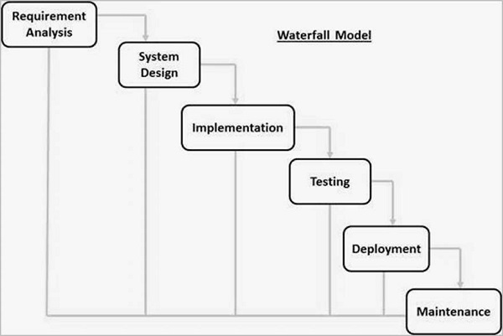

**Figure 3.1** Waterfall Model

The waterfall model contains six phases, as shown in Figure 3.1. The first is the system's requirements analysis where a list of possible needs will be gathered and then will be documented in a specific document. Second phases of waterfall model are system design which will cover the design of the application architecture. The component and functional testing will be implemented in the implementation phase. The testing phase is for integrating the generated unit into the system, where the system will test for failures or defects. When the application is ready to be deployed. The final step is the maintenance phase, during which the system is improved.

**3.2 Phase 1 Requirement Analysis**

The requirement analysis phase is the first and most important step of the software development lifecycle, where it gathers data to design a proper system. Some material connected to the project has been found through internet journals and publications to identify the needs needed in this project. The goal of this project is to develop a chat management system that will control the user chat activity. This project uses Progressive Web Application approach that has many advantages in a system development. The analysis is carried out by contrasting existing system related to chat management.

**3.3 Phase 2 System Design**

The design phase is the second phase of the waterfall model, and it describes how the system is designed. 3.3.1 displays the system's flow chart. Next, 3.3.2 will show the entity relationship diagram (ERD). It is followed by the use case diagram in 3.3.3. Lastly, in 3.3.4 the system design will be covered which depicts the system overview.

**3.3.1 Flowchart**

A flowchart is used to better comprehend the system's processes. The system flowchart is shown in Figure 3.1 and Figure 3.2.

**Figure 3.2** System flowchart

**Figure 3.3** System flowchart

First, the administrator needs to login into the system. If the login is not success, the administrator needs to login again and if the login is successful, the administrator has three choices to make that is chat room list option, user list option and report option. If the administrator selects chat room list option, the list of chat room will be display. Then, the administrator has three choices to be make that is update the chat room, delete the chat room, and add a new chat room. If the administrator selects to delete the chat room, all the information about the chat room will be deleted. If the administrator selects to update the chat room, the administrator needs to enter the chat room information and the chat room information will be updated. If add chat room option is being selected by the administrator, he or she needs to enter the chat room information a new chat room will be added to the system. But, if the administrator did not choose the chat room list option, he or she must select the other two option that is user list option and report option. If user list option selected, the system will display the list of the front-end user and then the administrator needs to choose either to ban or unban the user. The user will be banned if the administrator chooses to ban the user and vice versa if the administrator chooses to unban the user. The third option that can be made by the administrator is report option. The report detail will be display if the administrator chooses this option, and if there is no option that be made by the administrator, he or she can log out from the system.

**3.3.2 Entity Relationship Diagram**

The structural diagram, often known as the entity relationship diagram (ERD), is used in databases. It will show the structure and assist in database design in an ERD. Figure 3.4 depicts the database for this proposed system, as well as the relationships between the components.

**Figure 3.4** Entity Relationship Diagram (ERD)

Figure 3.4 shows the entity relationship diagram for the project that contains five entity table that is user, chat room, super admin, admin, and report that is tied to each other in the system. A user can make many reports about the abuse use of the front-end system and a user can create many chat rooms. A super admin can view, add, update, and delete admin. A super admin also can view the chatroom, view the report, and ban the user. An admin can view the chatroom and report information. An admin also can ban the user.

**3.3.3 Use Case Diagram**

Based on figure 3.3, there are five functions in the use case diagram. The administrator can block user, unblock the user, add a new chat room, delete the chat room, and view the report.

**Figure 3.5** Use Case Diagram

**Table 3.1** Use Case Description of Block User

|  |  |
| --- | --- |
| Use Case ID | UC 001 |
| Use Case | Block User |
| Purpose | To block a user who violate the rules |
| Actor | Admin |
| Trigger | Admin complete selection of the features |
| Precondition | Complete select all the features |
| Main Flow | 1. Admin select feature needed. 2. Admin select user and block the user. |

**Table 3.2** Use Case Description of Unblock User

|  |  |
| --- | --- |
| Use Case ID | UC 002 |
| Use Case | Unblock User |
| Purpose | To unblock a user |
| Actor | Admin |
| Trigger | Admin complete selection of the features |
| Precondition | Complete select all the features |
| Main Flow | 1. Admin select feature needed.  2. Admin select user and unblock the user. |

**Table 3.3** Use Case Description of Add Chat Room

|  |  |
| --- | --- |
| Use Case ID | UC 003 |
| Use Case | Add Chat Room |
| Purpose | To add a new chat room |
| Actor | Admin |
| Trigger | Admin click on features |
| Precondition | Admin need to enter all the data to be able to proceed |
| Main Flow | 1. Admin select feature needed.  2. Admin fill in all the information needed.  3. Admin click on the add button to add the new chat room. |

**Table 3.4** Use Case Description of Delete Chat Room

|  |  |
| --- | --- |
| Use Case ID | UC 004 |
| Use Case | Delete Chat Room |
| Purpose | To delete the chat room |
| Actor | Admin |
| Trigger | Admin click on features |
| Precondition | Complete select all the features |
| Main Flow | 1. Admin select feature needed.  2. Admin select the chat room and delete the chat room. |

**Table 3.5** Use Case Description of View Report

|  |  |
| --- | --- |
| Use Case ID | UC 005 |
| Use Case | View Report |
| Purpose | To view the report |
| Actor | Admin |
| Trigger | Admin click on features |
| Precondition | Complete select all the features |
| Main Flow | 1. Admin select feature needed.  2. System will display the report. |

**3.3.4 User Interface Design**

Figure 3.6 show the login page. The administrator needs to insert administrator ID and the password to login to the system.

**Figure 3.6** Login Page

Figure 3.7 and Figure 3.8 shows the chat room list interface where administrator can see the list of chat room that available in the system. Information of the chat room such as chat room name, chat room description, date of the chat room being created will be display here. Administrator will have two action to take either to update the chat room information or delete the chat room permanently. There is also search function to help the administrator to easily find the needed information. Figure 3.9 shows the menu bar option in the mobile view.

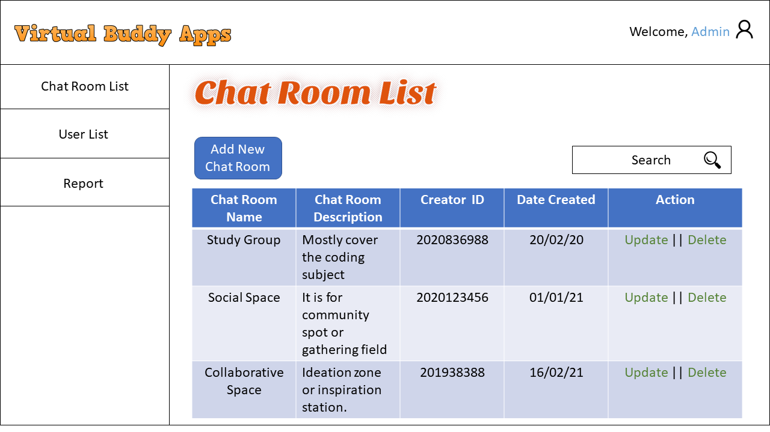

**Figure 3.7** Chat Room List Web View Design

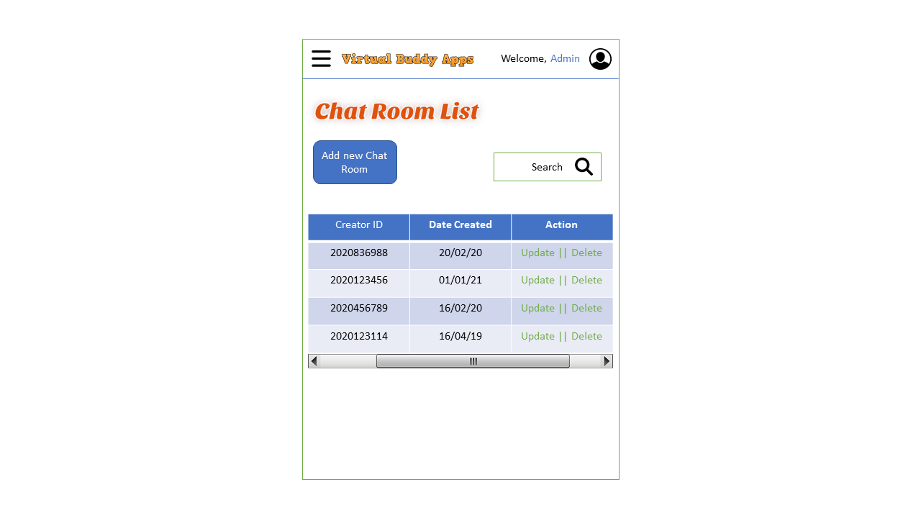

**Figure 3.8** Chat Room List Mobile View Design

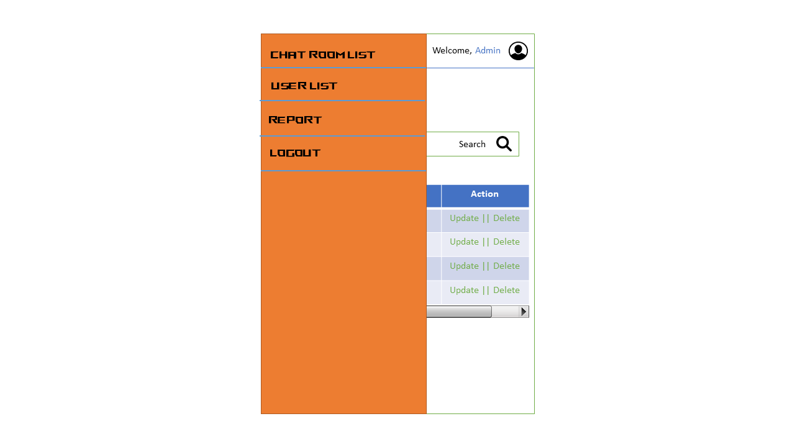

**Figure 3.9** Menu bar option in mobile view

Figure 3.10 and Figure 3.11 shows the add new chat room interface where administrator will fill in all the information needed such as chat room name, chat room description, welcome message, and chat room icon. The administrator then will click the add button to add the new chat room into the system.

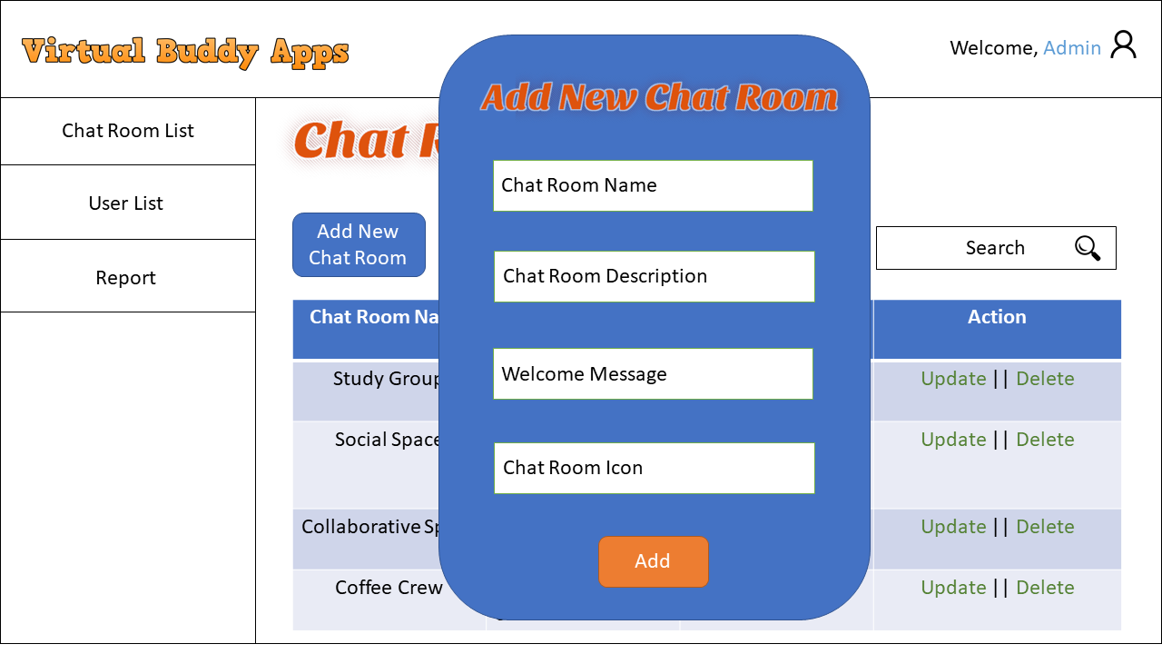

**Figure 3.10** Add New Chat Room Interface in Web View

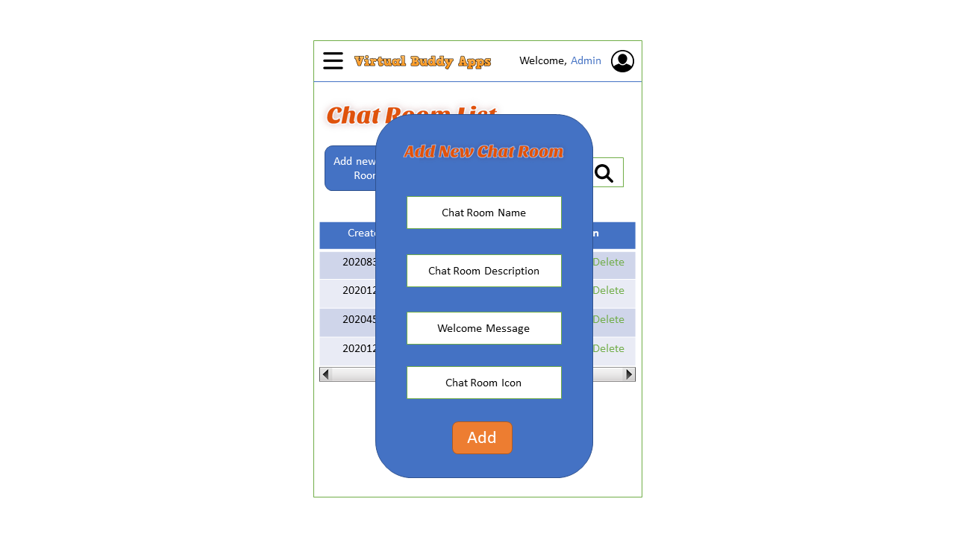

**Figure 3.11** Add New Chat Room Interface in Mobile View

Figure 3.12 and Figure 3.13 shows the user list interface where the information of front-end user such as full name, username and their course will be displayed here. The administrator has two action that can be taken that is block and unblock the user and delete the user permanently.

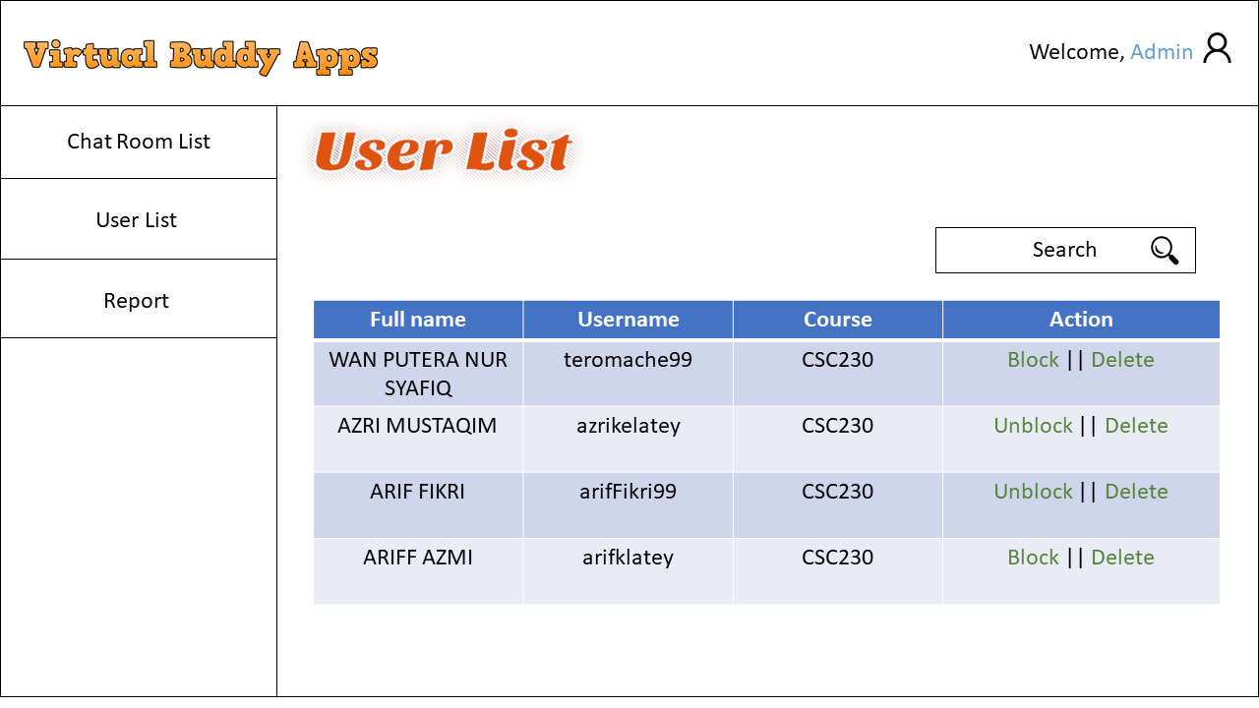

**Figure 3.12** User List Interface in Web View

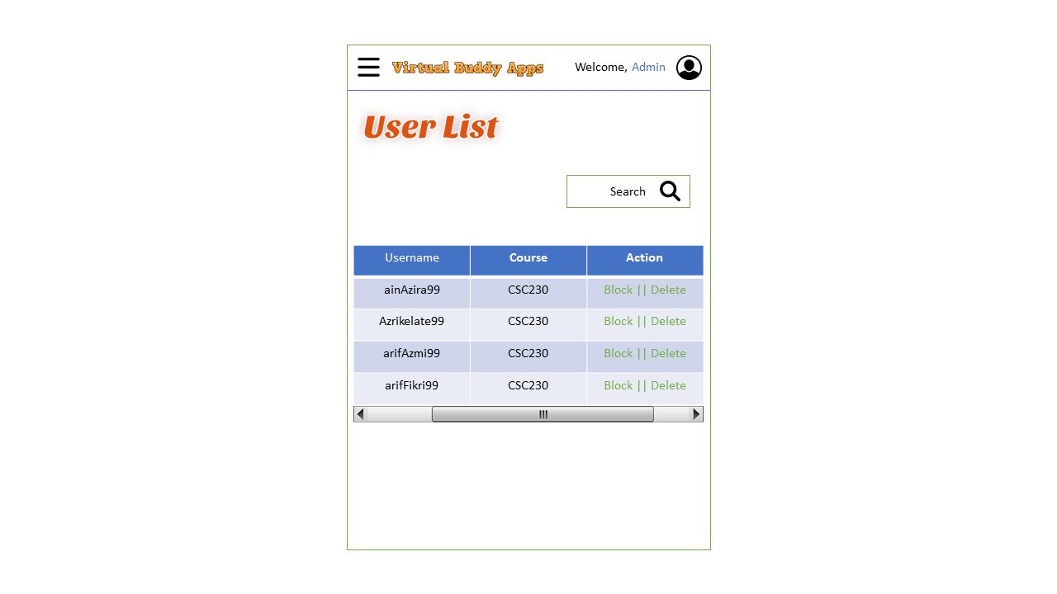

**Figure 3.13** User List Interface in Mobile View

Figure 3.14 and Figure 3.15 shows the report interface where the administrator can see the report that has been made by the front-end user. Information such as reporter username, offender’s username, report type, report description and report proof will be displayed here.

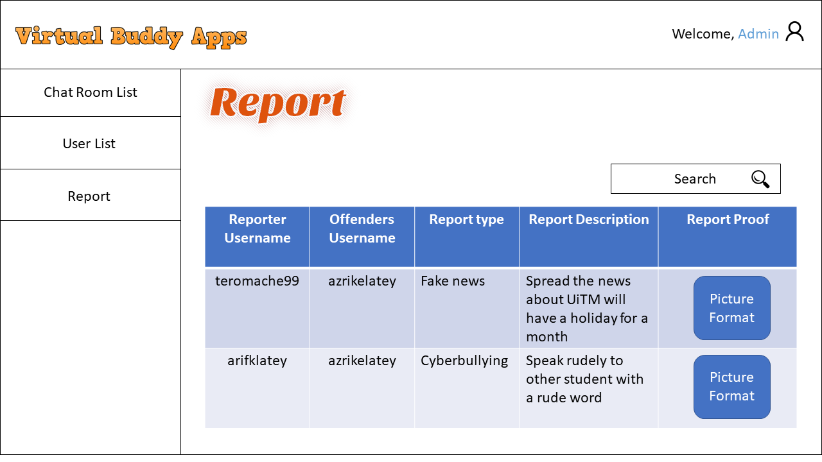

**Figure 3.14** Report Interface in Web View

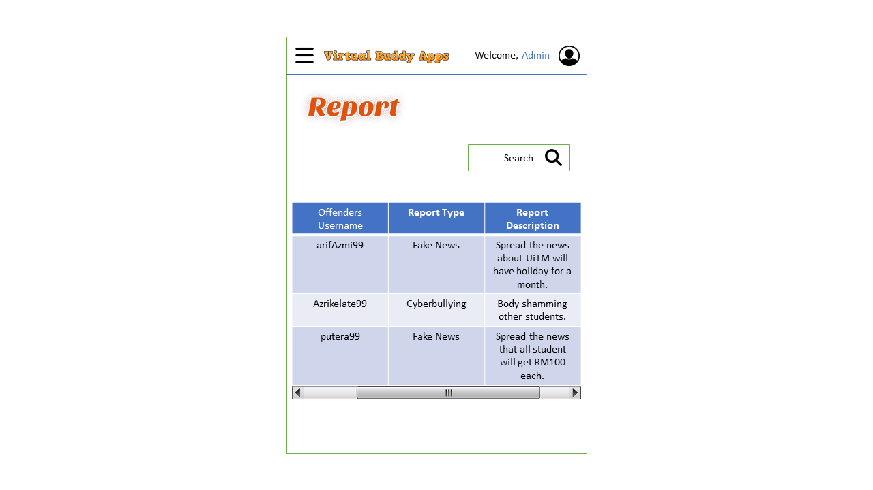

**Figure 3.15** Report Interface in Mobile View

**3.4 Phase 3 Implementation**

The technique, related tools, and software that will be employed in the proposed system are described in this section. The system is a Progressive Web Application where both PC and mobile user can use it. The software that will be used to construct the proposed system is shown in Tables 3.1 and 3.2.

|  |  |
| --- | --- |
| **HARDWARE** | |
| **Specification** | **Description** |
| OS name | Microsoft Windows 11 |
| OS manufacture | Microsoft Corporation |
| System type | x64-based pc |
| Physical ram | 16gb |
| Device memory | 1tb SSD and 1tb HDD |
| Device processor | Intel Core i7 10th Gen |
| Device graphic processor | Nvidia RTX2060 |

**Table 3.1**: Specification of device used.

The device specification that will be used to construct this project is shown in Table 3.1. Microsoft Windows 11 is the operating system on the device, while Microsoft Corporation is the manufacturer of the operating system. It has an 16GB random access memory (RAM) a 1tb SSD and 1tb HDD for read-only memory (ROM). Next, this device's processor is Intel Core i7 10th Gen. Finally, this device use Nvidia RTX 2060 for the graphic processor.

|  |
| --- |
| **Software** |
| Visual Studio |
| XAMPP |
| Google Chrome |

**Table 3.2**: Software Requirement.

The software that will be used to develop the system is shown in Table 3.2. The first piece of software is Visual Studio, which is used to write the code for the system. The proposed system data will then be stored in a database created with XAMPP. Then there's Google Chrome, where the preview of the system will be display here.

**3.5 Phase 4 Testing**

The prototyping phase is the next step. After the system has been completed, this phase will be completed. It is necessary to ensure that the system is free of errors. Each component of the system will be thoroughly examined to ensure that it functions properly.

**3.5.1 Test Case**

|  |  |  |
| --- | --- | --- |
| Event | Expected Outcome | Result |
| To test the functionality of user profile button. | It will be selected as one of its features. | Pass/Fail |
| To test the functionality of chat room navigation bar button. | It will display the content of chat room such as chat room name. | Pass/Fail |
| To test the functionality of update button in chat room content. | It will update the information of the chat room. | Pass/Fail |
| To test the functionality of delete button in chat room content. | It will delete the information of the chat room. | Pass/Fail |
| To test the functionality of add new chat room button in chat room content. | The chat room information form will be pop-up. | Pass/Fail |
| The system user fills the input needed in the add chat room form. | The new chat room will be added to the database and will be display in the chat room content. | Pass/Fail |
| To test the functionality of user list navigation bar button. | It will display the content of user list such as username. | Pass/Fail |
| To test the functionality of block user button in the user list content. | The selected user will be block. | Pass/Fail |
| To test the functionality of unblock user button in the user list content. | The selected user will be unblocked. | Pass/Fail |
| To test the functionality of report navigation bar button. | It will display the content of report such as reporter username. | Pass/Fail |
| To test the search function. | The search content will be display based on input keyword. | Pass/Fail |

**Table 3.3**: Test case for the button of the input data and output data interface.

**3.6 Phase 5 Deployment**

Deployment occurs at the conclusion of the development process. Once testing is completed, the application is ready for deployment. The programme is available in the appropriate app store for end-user use.

**3.7 Phase 6 Maintenance**

This is the project's last phase, during which it will do system maintenance when faults or bugs are identified. This phase will begin only after the system has been completed. This is also the phase when any system updates or improvements will be introduced.

**3.8 Summary**

To summarise, the ideal technique to design a mobile application is to use the waterfall model of the Software Development Life Cycle (SDLC). Requirement analysis, system design, implementation, testing, deployment, and maintenance are the six phases of the waterfall model. The previous section provided detailed information on each phase.

**REFERENCES**

A. Biorn-Hansen, T. A. Majchrzak, and T.-M. Gronli (2018). Progressive Web Apps For the Unified Development of Mobile Applications in *Web Information Systems and Technologiesm*, 64-86’.

Andreas Biørn-Hanse, Christoph Rieger, Tor-Morten Grønli, Tim A. Majchrzak & Gheorghita Ghinea (2020). An Empirical Investigation of Performance Overhead in Cross-Platform Mobile Development Frameworks. *Empirical Software Engineering.* 25 : 2997-3040. <https://doi.org/10.1007/s10664-020-09827-6>

Annita Ashutoshbhai Mangukiya (2020). Laravel: A Framework for Building PHP Apps. <http://dx.doi.org/10.13140/RG.2.2.25131.26402>

Arum Nisma Wulanjani (2018). DISCORD APPLICATION Turning a Voice Chat Application for Gamers into a Virtual Listening Class. *2nd English Language and Literature International Conference (ELLiC) Proceedings.*2.

A.Subari, S Manan & E Ariyanto (2020). Design of E-Office System in Vocational School Diponegoro University Using Code Igniter Framework. *IOP Conference Series: Materials Science and Engineering,*801(1)*.* doi:10.1088/1757-899X/801/1/012141

Azwa Rahman (2020). *“UiTM Nafi Akan Ambil Tindakan Terhadap Pelajar Yang Menyertai Petisyen Perletakan Jawatan Vivy Yusoff”.* https://gempak.com/berita-terkini/uitm-nafi-akan-ambil-tindakan-terhadap-pelajar-yang-menyertai-petisyen-perletakan-jawatan-vivy-yusof-34425

C J Gómez-Sierra (2021). Design and Development of a PWA - Progressive Web Application, to Consult the Diary and Programming of a Technological Event. *IOP Conference Series: Materials Science and Engineering*, 1154(1)*.* doi:10.1088/1757-899X/1154/1/012047

Detik.com (2017). *“Awas Hoax! Kabar Tipuan yang Mematikan”.* <https://inet.detik.com/cyberlife/d-3122471/awas-hoax-kabar-tipuan-yangmematikan>.

Divyam Goyal, Pulkit Jain & Bharat Bhushan (2020). Enhancement of Security using Various Web Development Frameworks. *Proceedings of the International Conference on Innovative Computing & Communications (ICICC).* https://dx.doi.org/10.2139/ssrn.3600740

Erika Heidi (2020). How to Use Migrations to Create and Manage Database Tables in Laravel. https://www.digitalocean.com/community/tutorials/how-to-use-migrations-to-create-and-manage-database-tables-in-laravel

Franny Harold (2021). *“4 Examples of Great Online Communities and What Makes Them Work.”* <https://khoros.com/blog/great-online-communities>

Gumgum Gumelar, Zarina Akbar & Erik (2018). Engagement and the Spread of Fake News. *Advances in Social Science, Education and Humanities Research. 165.*

Hang Zhang, Xiaohua Sun, Liang Chen, Hongze Yang & Yandong Wang. The Meditation Role of Moral Personality Between Childhood Psychological Abuse and Cyberbullying Perpetration Attitudes of College Students (2020). *Frontiers in Psychology.* 11 : 1215. doi: 10.3389/fpsyg.2020.01215

Hannah Gaffney, Dorothy L Espelage, David P.Farrington & Maria M. Ttofi. (2018). Are cyberbullying intervention and prevention programs effective? A systematic and meta-analytical review. *Aggression and Violent Behaviour. 45.* doi: 10.1016/j.avb.2018.07.002

Jeel Patel (2021). “*Top 8 Backend Frameworks to Use in Web App Development.”* <https://www.monocubed.com/best-backend-frameworks/>

Jennifer L. Betts (2019). “*Create a Virtual Friend.”* https://teens.lovetoknow.com/Create_a_Virtual_Friend

John, A., Glendenning, A. C., Marchant, A., Montgomery, P., and Hawton, K. (2018). Self-harm, suicidal behaviours, and cyberbullying in children and young people: systematic review. J. Med. Int. Res. 20, e129.

John Prabhu (2019). *“MVC Architecture & Its Benefits in Web Application Development.”* <https://www.simform.com/blog/laravel-vs-codeigniter/>

Kompas.com (2017, Aug 20). *“Panasnya Media Sosial Gara-gara Berita Hoax”.* http://ekonomi.kompas.com/read/2017/01/24/06060001/panasnya.media.s osial.gara-gara.berita.hoax.?page=all.

ladychampionz (2020).*” Active Chat Monitoring and Suspicious Chat Detection over Internet”.* <https://projectchampionz.com.ng/2020/04/18/active-chat-monitoring-and-suspicious-chat-detection-over-internet/>

Liz (2020). *“What is a Social Community?”* <https://www.successful-blog.com/1/what-is-a-social-community/>

Mantra Malhotra (2021). “*CodeIgniter vs CakePHP vs Yii vs Laravel : Which Framework Would You Choose in 2021?.”* <https://www.valuecoders.com/blog/technology-and-apps/codeigniter-vs-cakephp-vs-yii-vs-laravel/>

Michael Longley & Yasmine N. Elglaly (2021). Accessibility Support in Web Frameworks. In *The 23rd International ACM SIGACCESS Conference on Computers and Accessibility (ASSETS ’21)*. https://doi.org/10.1145/3441852.3476531

Mole, Patrick V. (2020). Progressive Web Apps: A Novel Way for Cross-Platform Development.

Nazar Kvartalnyi (2021). *“Benefits of Progressive Web Apps (PWA) – Advantages and Disadvantages.”* <https://inoxoft.com/blog/benefits-of-progressive-web-apps-pwa-advantages-and-disadvantages/>

Oluwatofunmi Adetunji, Chigozirim Ajaegbu, Nzechukwu Otuneme & Olawale J. Omotosho (2020). Dawning of Progressive Web Application (PWA): Edging Out the Pitfalls of Traditional Mobile Development. *American Scientific Research Journal for Engineering, Technology, and Sciences (ASRJETS),*68(1),85-99.

Parbat Thakur (2018). Evaluation and Implementation of Progressive Web Application.

Parkavi A, Sowmya B J & Pushpalatha M N (2020). “FRIENDLY CHAT” – A chat application with multi-headed classification models for identifying abusive levels and their comparative study. *Journal of Physics: Conference Series.* 1706. doi:10.1088/1742-6596/1706/1/012145

Raveena Nagotra (2021). *”Pensyarah UiTM Didakwa Buat Gangguan Seksual”. https://www.malaysiakini.com/news/579466*

TribunnewsBogor.com (2017, Aug 20). *“Begini Cara Mendeteksi Berita Hoax, Kalimat ‘Dari Grup Sebelah Patut Dicurigai”.* <http://bogor.tribunnews.com/2016/11/09/begini-cara-mendeteksi-beritahoax-kalimat-dari-grup-sebelah-patut-dicurigai?page=all>.

Yakob Utama Chandra, Surjandy & Ernawaty (2017). Higher Education Student Behaviours in Spreading Fake News on Social Media: A Case of LINE Group. *International Conference on Information Management and Technology.*54-59.

Yuan, L. Y., Chen, L. L., and Pan, L. Y. (2017). Current situation of cyberbullying

and its effect on suicidal ideation in Nanning university students.

*Chinese J. Sch. Health*. 38, 945–947. doi: 10.16835/j.cnki.1000-9817.

2017.06.048

Yusuf Kurnia & Refin (2020). Ayam Gepuk Pak Gembus Web-Based Ordering Application Design with Codeigniter Framework. *Bit-Tech*,2(2),65.

Zsila, Á, Róbert, U., Griffiths, M. D., and Demetrovics, Z. (2019). Gender differences in the association between cyberbullying victimization and perpetration: the role of anger rumination and traditional bullying experiences. Int. J. Mental Health Addict. 17, 1252–1267. doi: 10.1007/s11469-018-9893-9

Zych, I., Baldry, A. C., Farrington, D. P., & Llorent, V. J. (2018). Are children involved in cyberbullying low on empathy? a systematic review and meta-analysis of research on empathy versus different cyberbullying roles. Aggress. Violent Behav. 45, 83–97.

APPENDICES

APPENDIX 1

Gantt Chart

